Personal assistance for seniors who are self reliant

1.introduction

1.1.project overview

* An app is built for user (caretaker) which enables him to set the desired time and medicine.this details will be stored in the IBM cloud and DB.
* If the medicine time arrives the web application will send the medicine name to the iot device through the IBM iot platform.
* The device will receive the medicine name and notify the user with voice commands

1.2.purpose

* Sometimes elderly people forget to take their medicine at the correct time
* They also forget which medicine he or she should take at the particular time
* And it is difficult for doctors or caretakers to monitor the patient around the clock.to avoid this problem ,this medicine reminder system is developed.

2.literature survey

2.1.Existing problem

Elderly people let slip the medication at the correct time and the existing solutions for this problem is setting reminders or using pill boxes ,calenders personal assistance.though the solutions give reminders ,the voice commands or assistance given by the system is more efficient.

2.2.references

1. Visual health reminder :A reminder for medications in take and measuring blood pressure to support elderly people ;Rene barayani;sascha rainer;Stefan schlossarek;nadja ledered;Thomas grecheing
2. Cloud computing based medical assistance & pill reminder ;A.chinnasamy;Ram Prasad J;syed rafeeq ahmed ; Akash S

2.3.problem statement definition

Skipping medicines can be serious for some medical health conditions ; sometimes elderly people forget to take their medicines at the correct time . they also forget which medicine one should take at that particular time .and it is difficult for doctors or care takers to monitor patient around the clock

3.ideation and proposed solution

3.1.Empathy map canvas

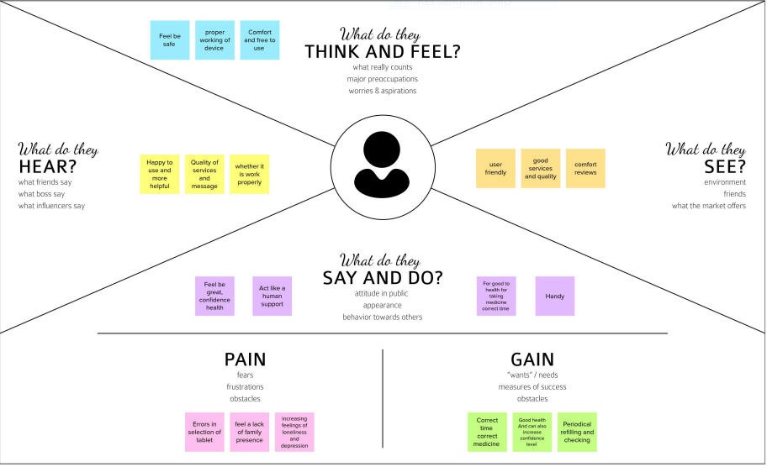

3.2.Ideation and brain storming

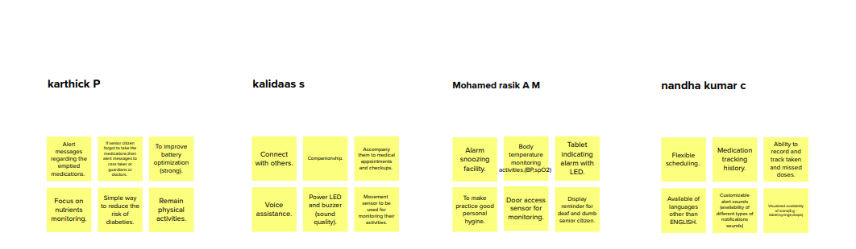

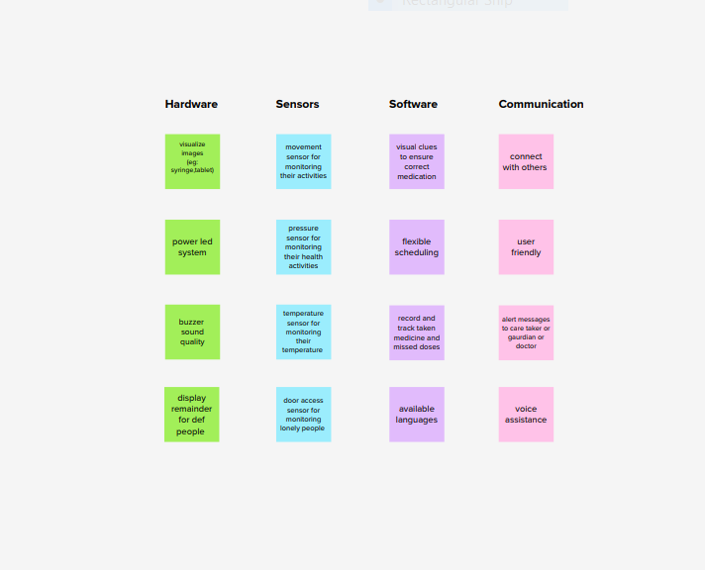

3..3.Proposed solution

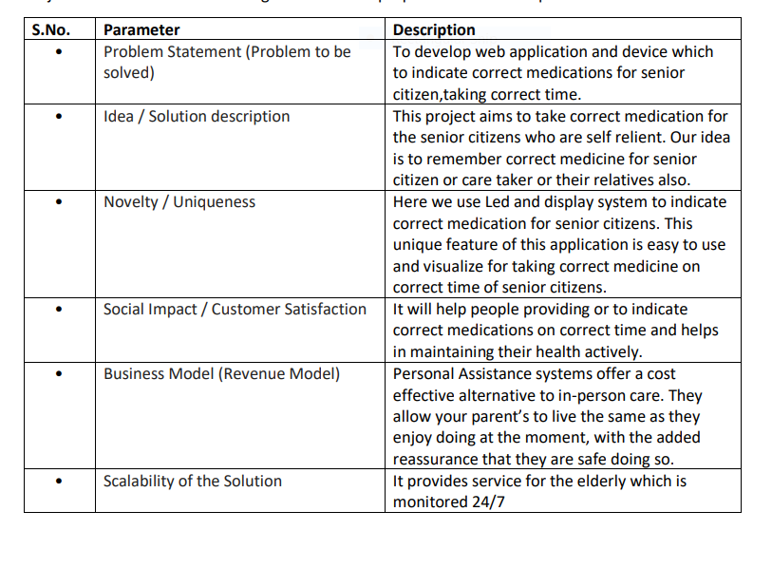

3.4.Problem solution fit

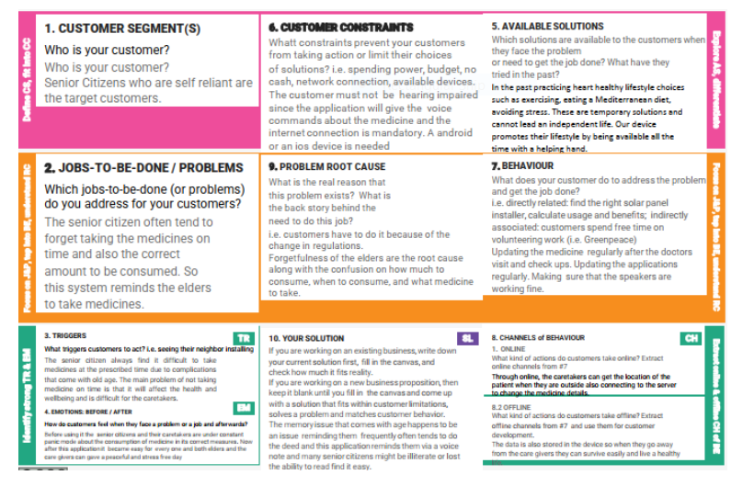

4.Requirement analysis

4.1.Functional requirements

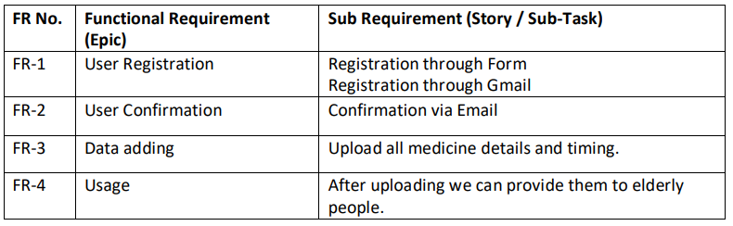

4.2.Non-functional requirements

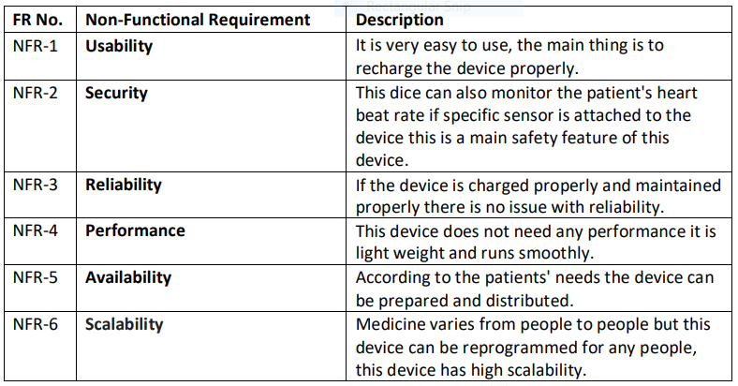

5.Project design

5.1.Data flow diagram

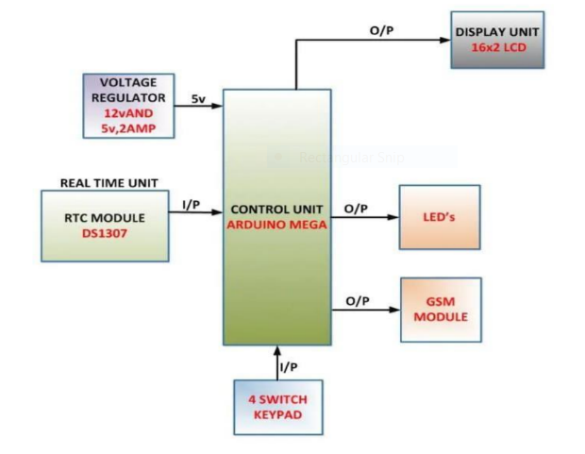

5.2.technical architecture

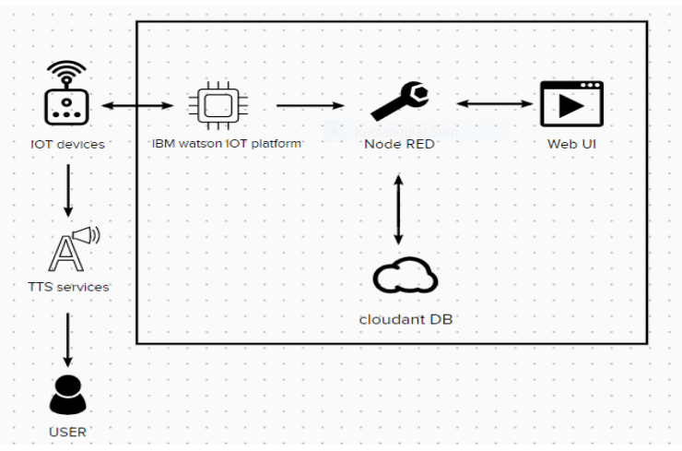

5.3.User stories

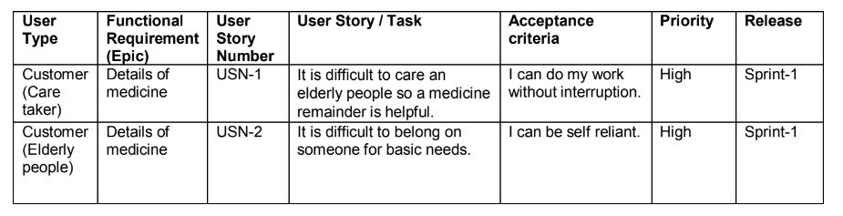

6.Project planning and scheduling

6.1.Sprint planning and estimation

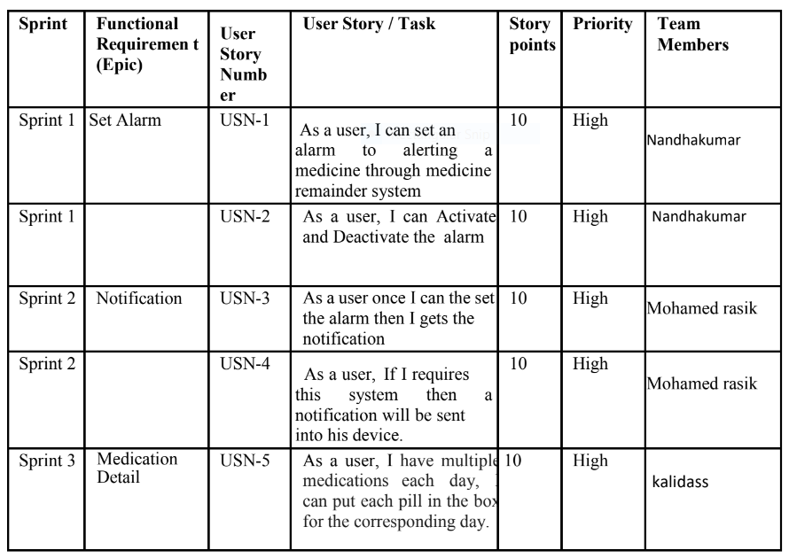

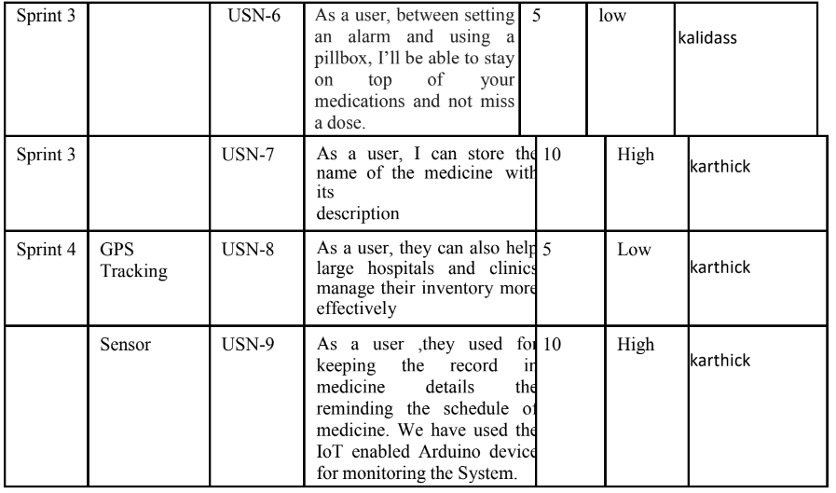

6.2.Sprint delivery schedule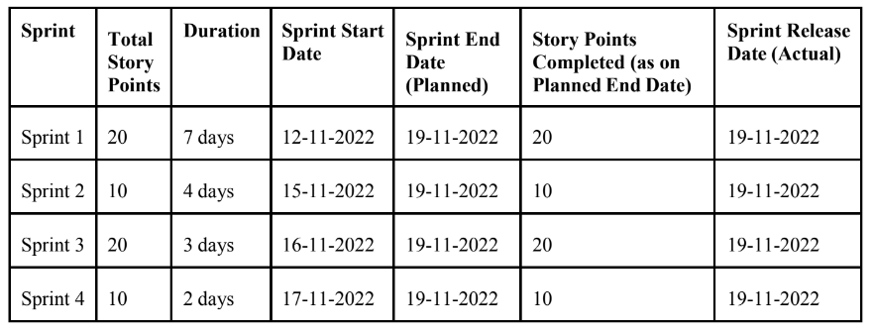

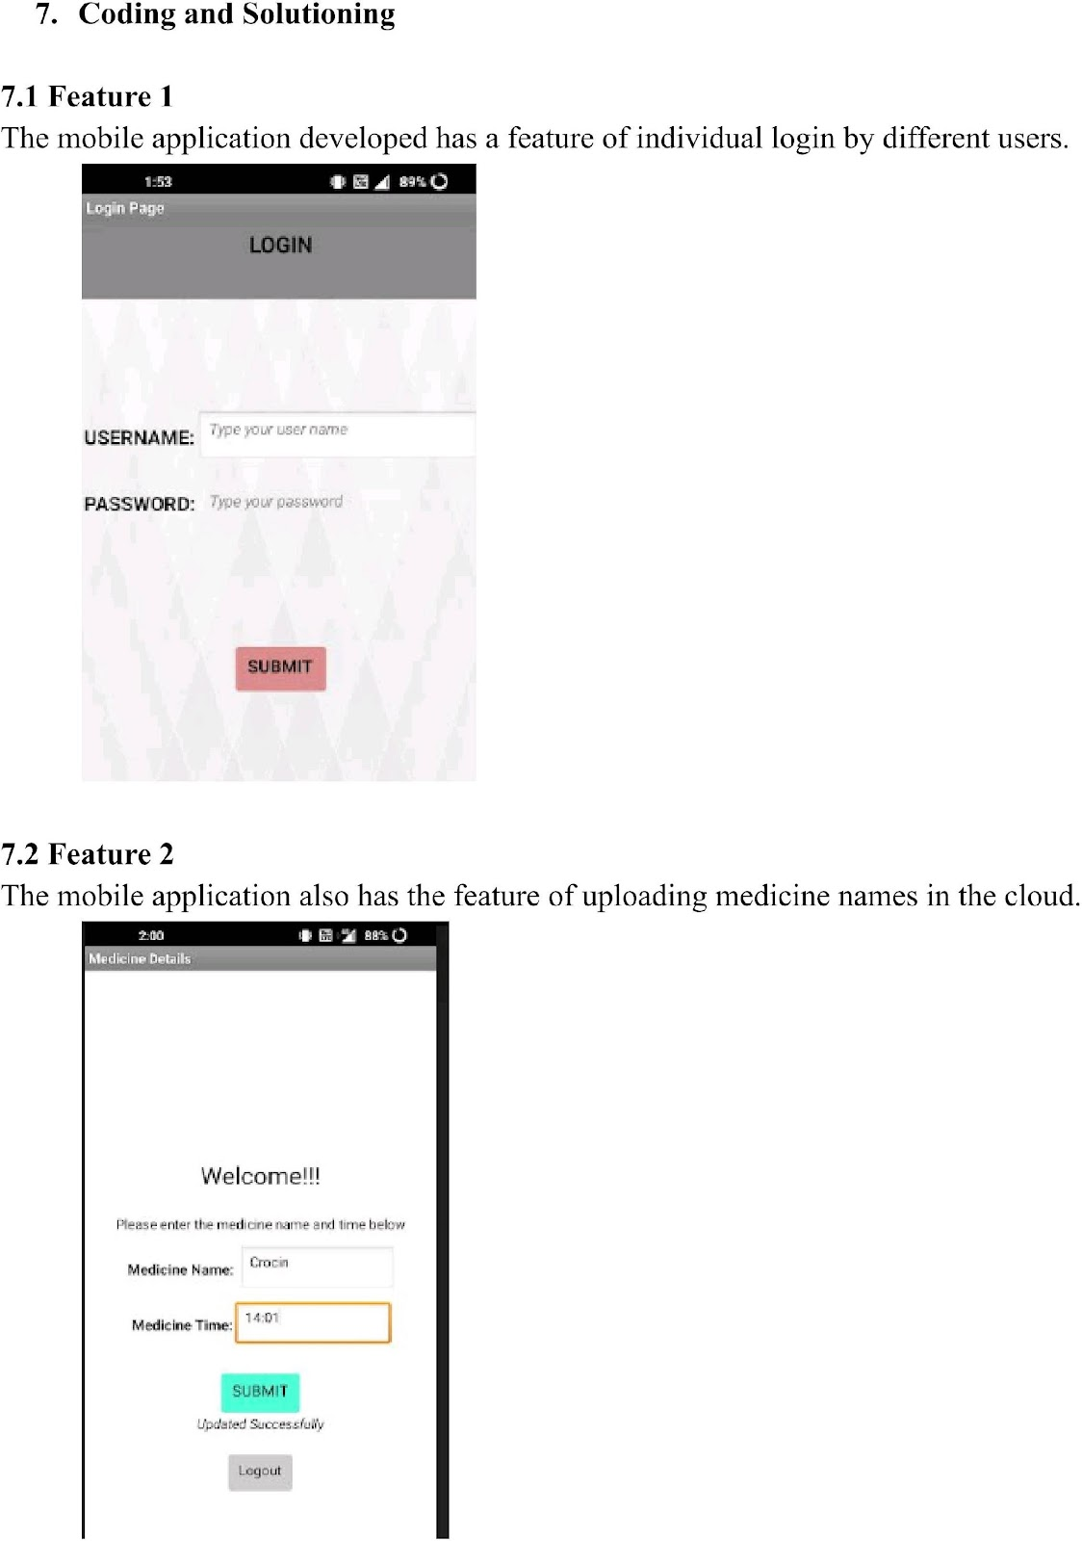

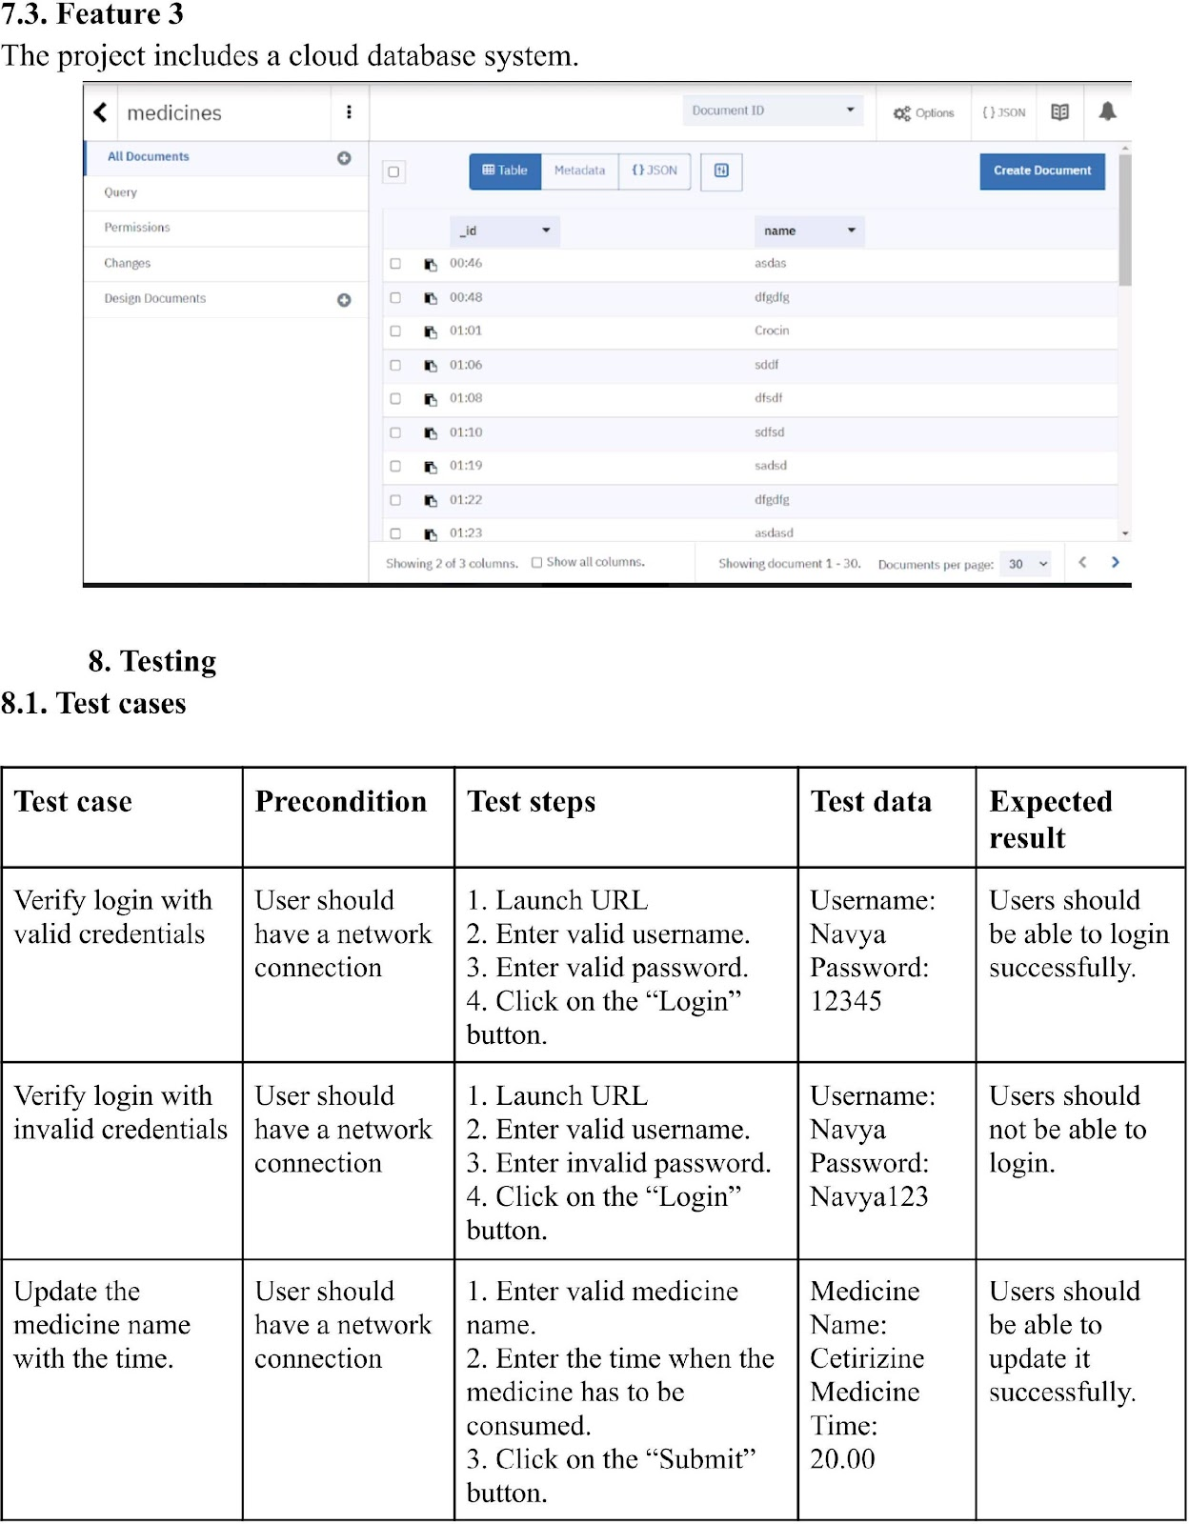

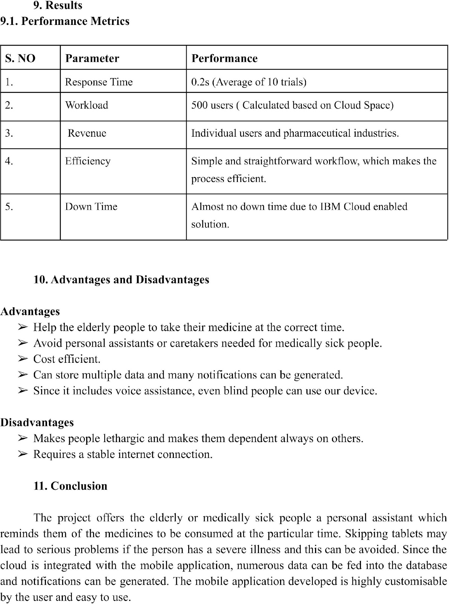

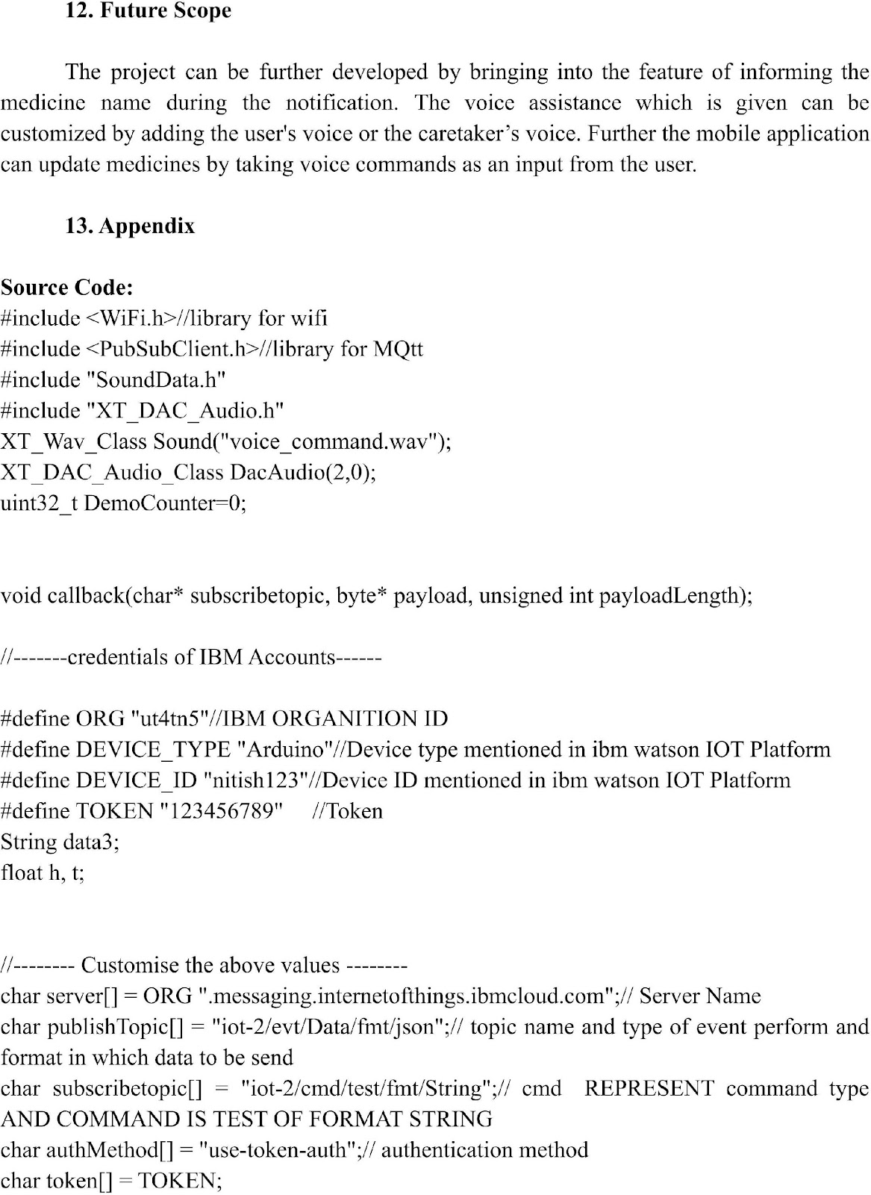

Demo link : [https://www.mediafire.com/file/heakocu5tnfb11i/VID-20221119-WA0017[1].mp4/file](https://www.mediafire.com/file/heakocu5tnfb11i/VID-20221119-WA0017%5B1%5D.mp4/file)